GPS Web Tracking Platform
Server address:www.twogps.com
Support Language:
中文
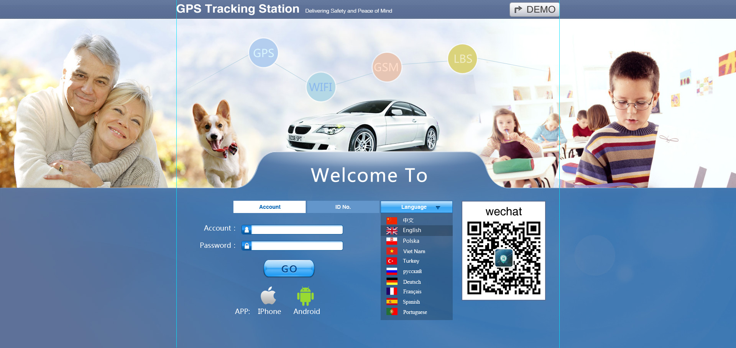
English
Polskie
Việt
Thổ Nhĩ Kỳ
русский
français
Deutsch
Español
português

Part 1(For End users):
- Login the account(unireach;123456)
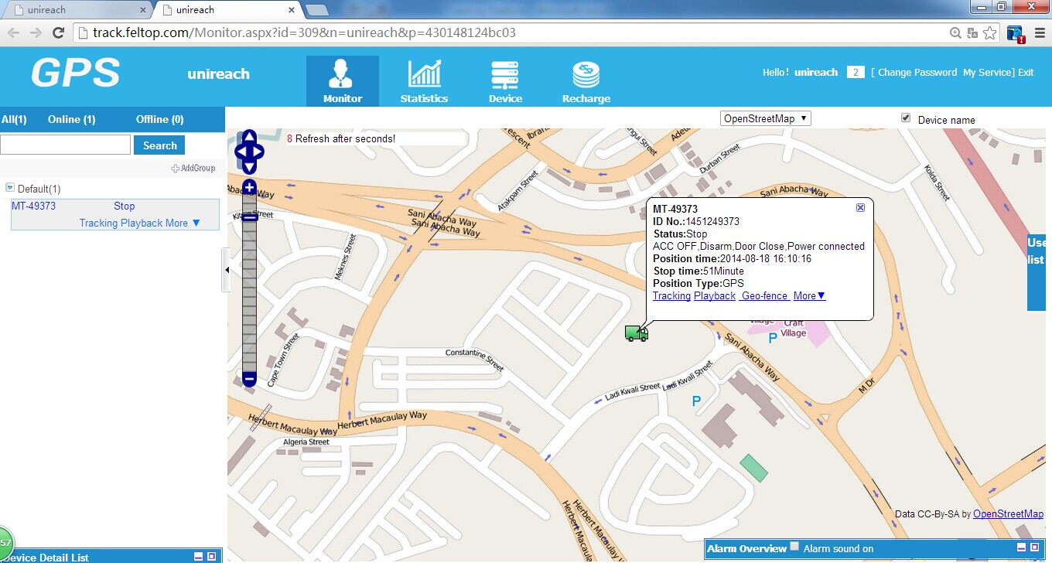

2.Device info:here input GPS device informations,GPS name,phone numbers and so on.
Color of the GPS name:
Blue:Stop
Green:,Moving
Grey: offline(some tracker devices maybe enter sleep mode when not moving.If it is offline for long time(over 5 days),it should have problem with simcards or GPS devices,contact us freely).
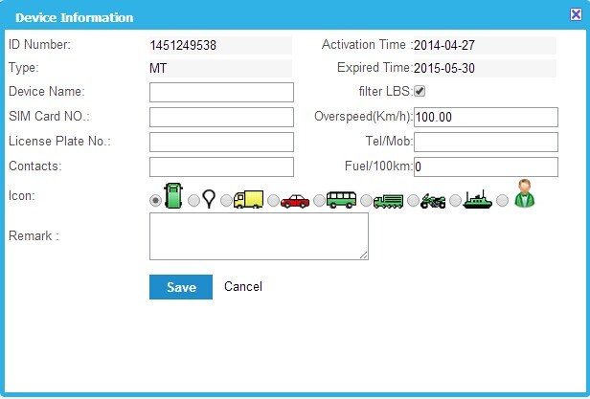

3.information of user
1).Time zone: click on user name according to picture as below,select correct time zone.
2)Alert email: you can input email address here,so when there is alarms,platform will send email to the email address.
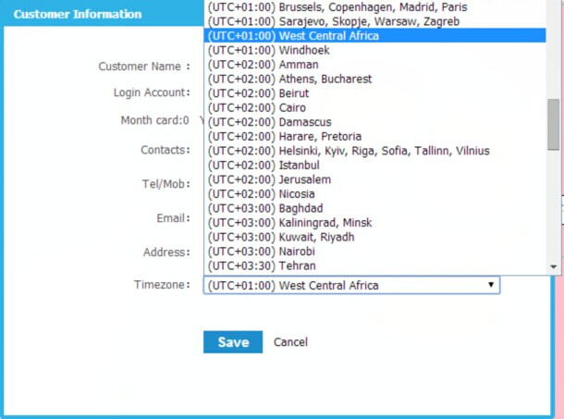

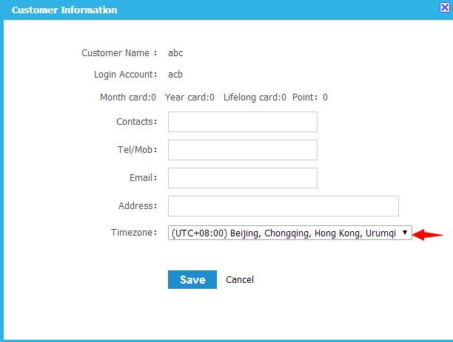

4.Set Geo-fence on map:
1).Keep pressed on the center point of the circle to move on map,move to the place where you want to mark as center of geo-fence .
2).Then keep pressed on the circle to zoom/zoon the circle(distance of geo-fence).
3).At last,input geo-fence name and click “save” to save the setting.
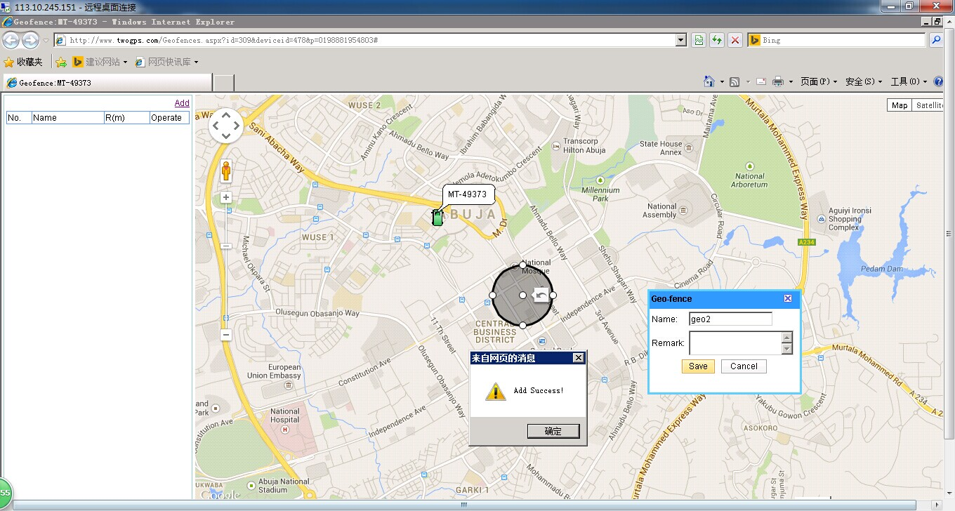

5.Group Move:
6.Cut off Engine
7. Engine Restore
8.Arm/Disarm

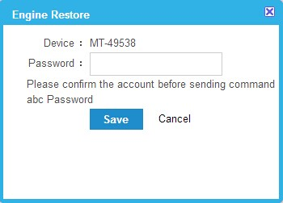

11.Issued Commands:Check the commands has sent from platform.
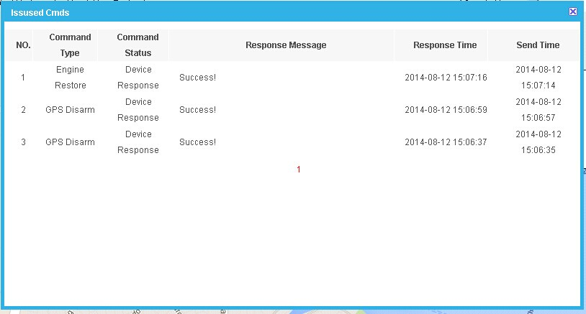

12:KML history:Download the google history reports in KML google format.After installed googleearth in computer,you can check the history reports on map anytime.
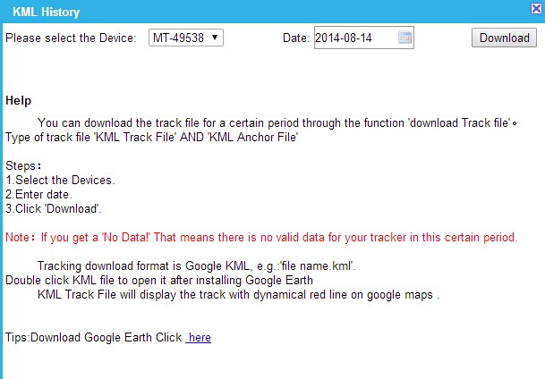

13:POI,create Points of interests on google map,it can save all the points on the platform.
1).Click on “Add POI”to add interest point,keep pressed on red mark to move on the map. 2).input name to save this point on google map.
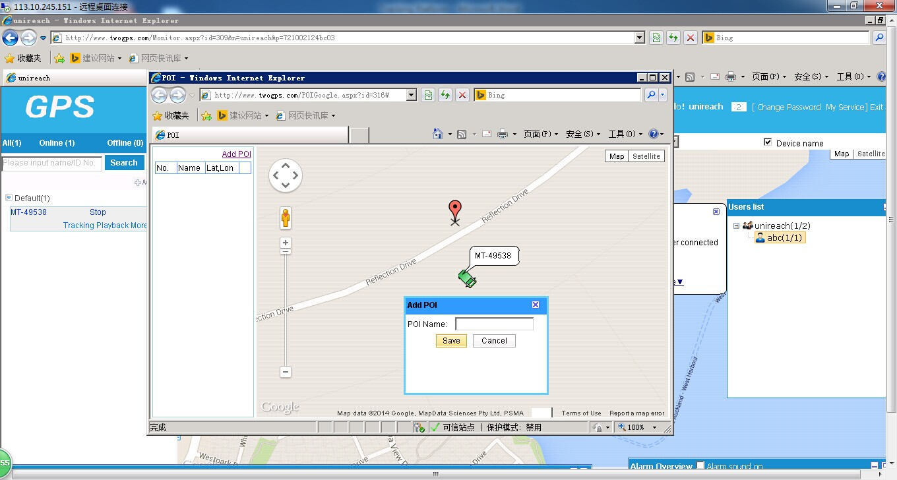

14:Tracking:You can realize realtime tracking from this page.
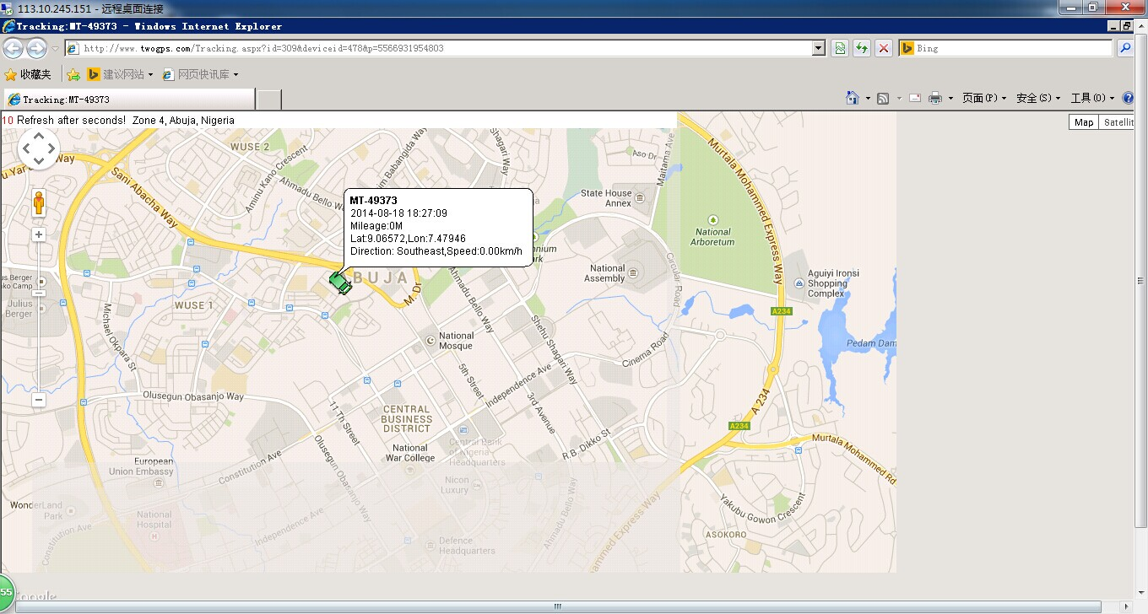

15:Play back:Play the history on google map.
1).Details:Clock on “details”to get reports details online.
2).Download:reports details can be downloaded in excel format.
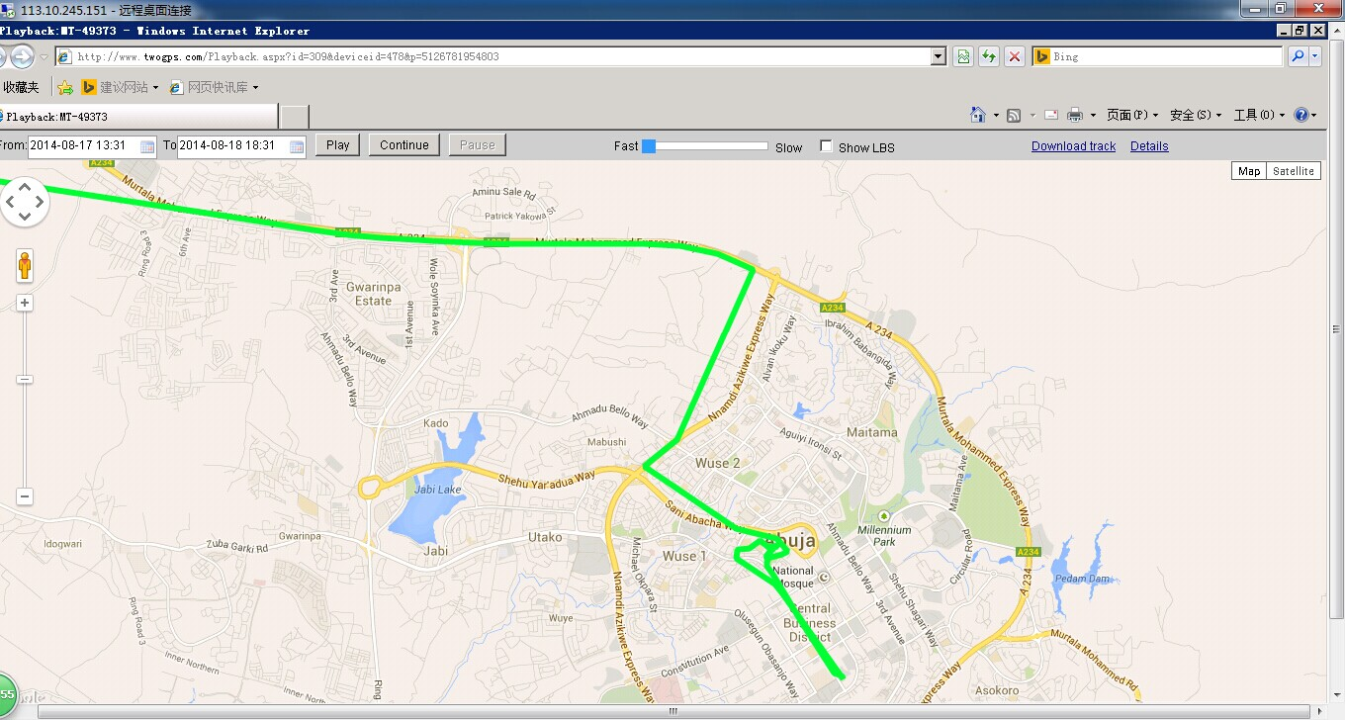

16:Statistics:
All kinds of alarms can be checked online from here and downloaded.
(Geo-fence alarm,overspeed alarms,sos alarms,stop details,moving details,mileage,)
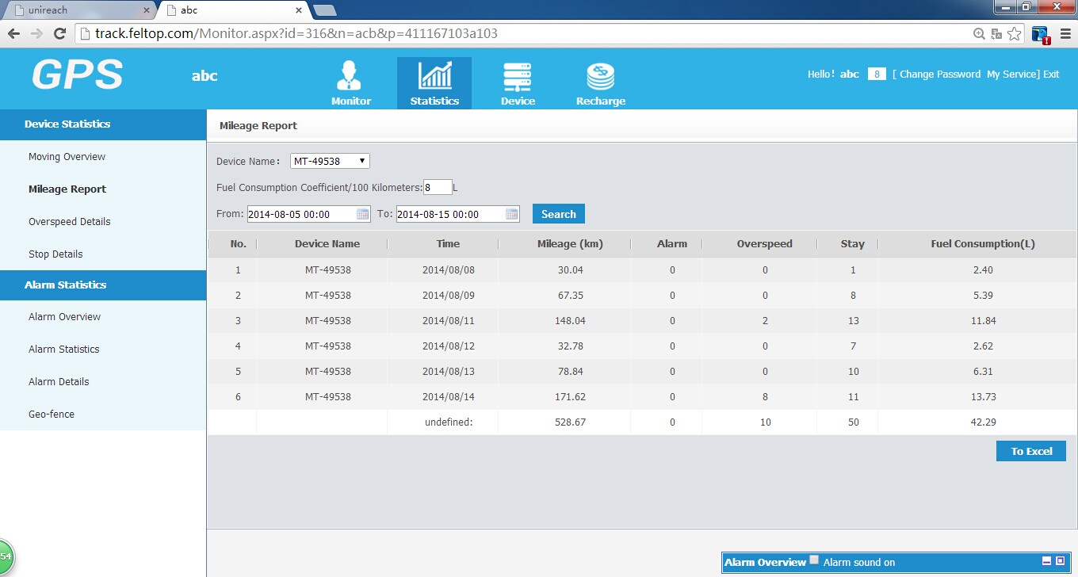

Part2: (For distributors only)Tracker/ user Mangement.
- Add accounts
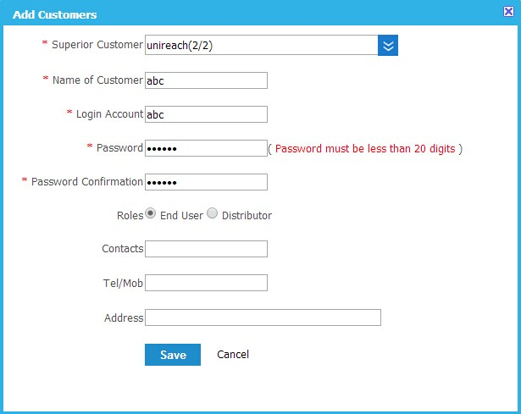
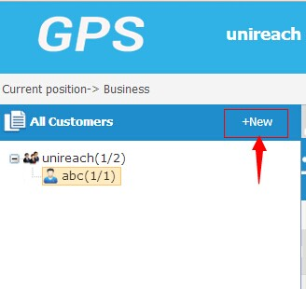

3.Move Devices:
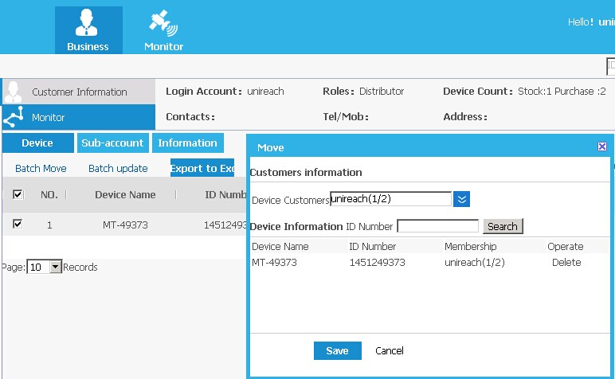

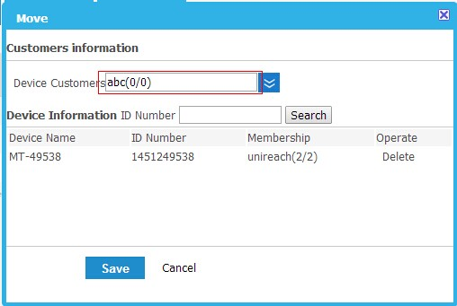

4.Export Device list,(save as excel format):

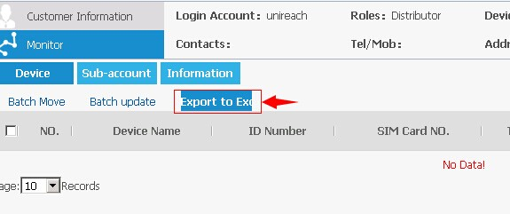

APP:
Download the app from homepage of platform:www.twogps.com
Click on”Iphone” or”Android” to download the app,and install in your phone.
Input same account as website platform,server:www.twogps.com

